Continuidad Pedagógica.
6th grade.
Name:

Leer el texto y responder las preguntas en la carpeta (NO es necesario imprimir ni copiar la lectura)
- Finalización tramite registración Read the e- mail and answer the questions. Imagine you are Peter.
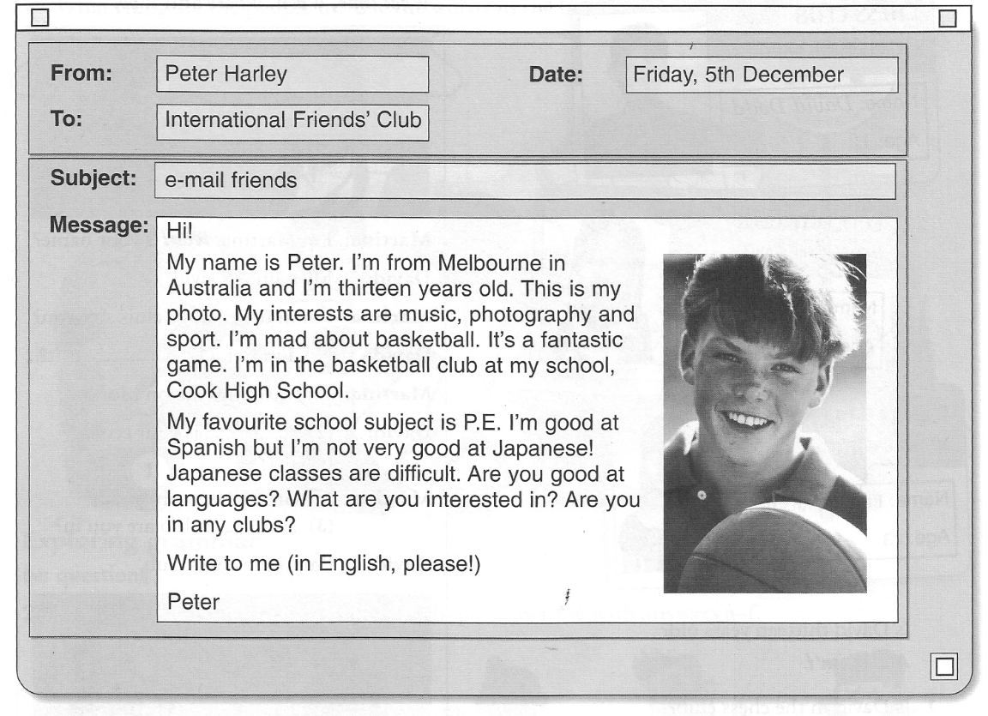
a) What’s your name?_____________________
b) Where are you from?______________________
c) How old are you?__________________________
d) What’s your favourite sport?_____________________
e) What is the name of your school?_________________________

2) Write TRUE or FALSE

- It is Sunday_____
- Peter is Australian._____
- He likes music, photography and English.
- His favourite subject is Physical Education____
- He likes Japanese

3)Complete about you.

NAME:: SCHOOL:
AGE: LIKES
COUNTRY/NATIONALITY: DISLIKES:
FAVOURITE SUBJECT ABILITIES

4) Write your own e-mail

Hello:
My mane is ____________________
______________________________years old.
I’m from_____________________________
My favourite ______________________
I like_____________________________but I don’t like______________________________
I can__________________________________

